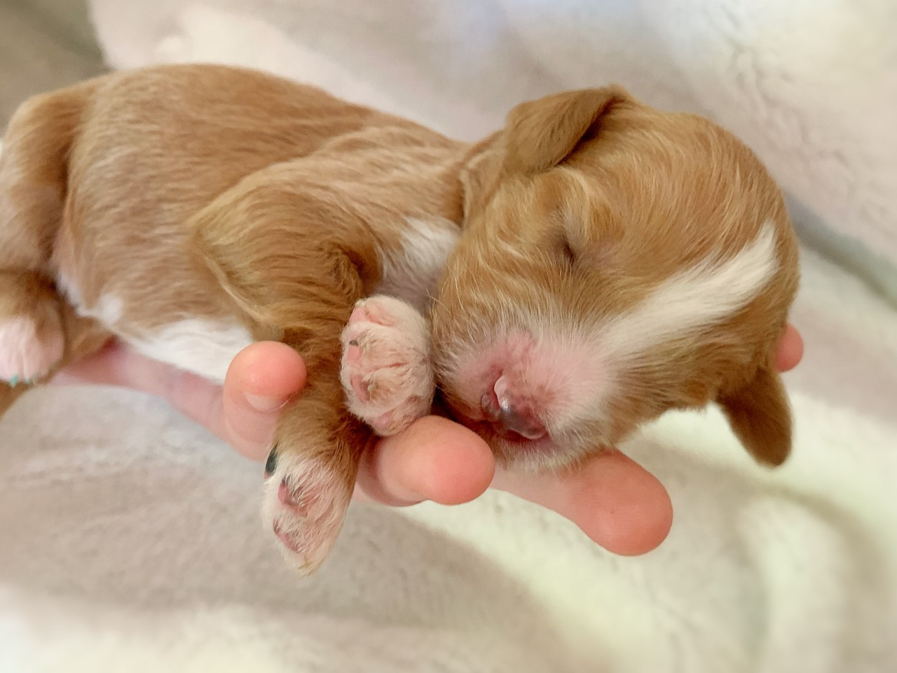

Health Guarantee and Spay/Neuter Contract

DOB: _____________ Sex:__________ Color or collar color: ___________________

Sire: STANDARD POODLE (GILBERTO) Dam:___________
*Buyer’s Name: _____________________________

*Buyer’s E-mail:___________________________
*Buyer’s Address: *City: ______________________

*State: __________________ *Zip: _________________
*Phone Numbers:___________________
Sale Date: _______________________

Deposit: ________ Due at pick up Total price: ________________
**From here in the “seller” will be referred to as Paul Horsley

Paul Horsley guarantees puppy to be in excellent health and condition when purchased. Puppy has received all age appropriate shots and de worming by Paul Horsley. He/She has been well socialized and loved.
**Buyer agrees to take puppy to a licensed veterinarian within 5 days of receiving puppy for a health check to make sure the puppy is free of illness and any life threatening, congenital disorders. Paul Horsley must be notified immediately of the outcome of the checkup. Failure to do so will result in this contract being null and void. ________ (initial please).

If puppy is found to be unfit for sale due to illness, which is clearly attributable to the seller, or have a life threatening, congenital disorder. Paul Horsley will replace puppy with another puppy of equal value and sex provided that the buyer:

- Have written documentation from veterinarian of the illness or life threatening, congenital defect.
- Return puppy as soon as possible with all documents that were received with the puppy Buyer understands that.

Buyer understands that owning a puppy requires much care, training, and routine veterinary care, the buyer understand that the puppy will need additional puppy shots as well as altering.
Paul Horsley will not be responsible for any veterinary fees or behavioral issues.
Paul Horsley has a replacement guarantee on puppies up to 12 months of age.
If in that 12 months the puppy should develop a life threatening, hereditary disorder.
I will replace the puppy for another puppy of equal value and sex at the soonest
availability, provided the following conditions are met.

- Buyer will provide Paul Horsley written notification from 2 separate licensed veterinarians of the life threatening, hereditary disorder.
- Buyer agrees to keep up with all vaccinations, flea medication, routine worm checks, heart worm treatments, and keep records of doing such should the puppy ever have to be returned.
- If puppy should die buyer must provide a copy of the autopsy report that states a life threatening, hereditary defect was the cause of death.
- Buyer will be responsible for any veterinary fees and shipping costs involved in getting a replacement puppy.
- Seller will not be responsible for cost accrued by buyer; such as vet cost of purchased puppy, cost of food, housing etc.

Paul Horsley will not be responsible for minor bacterial infections that can be contracted during move of puppy such as coccidian, and kennel cough. These are easily treated and can be brought on by the stress of moving to a new home. Paul Horsley will not be responsible for intestinal parasites, mange. giardia or other common diseases that are easily treated.
This guarantee does not include environmental, nor common airborne viruses, any abnormalities in bite or hernias, pinched nostrils or retained testicles. SIZES and COLORS are estimates only.
Paul Horsley makes no guarantee on color, size or, temperament.
The buyer releases Paul Horsley as owner/operator of and/or damages by fault of the puppy after the time of sale. These damages include, but are not limited to: destruction of property and/or physical same and their estate, from any liabilities damage to any person or group of people by puppy.
Any legal action must take place in the county and state in which the seller resides at the time of legal action. Upon transfer of puppy to another person, this contract and guarantee becomes null and void.
Buyer agrees that he/she has researched the breed and understands all of the requirements of owning, training, and caring for this puppy. Buyer agrees to feed puppy a quality food, keep puppy in good body condition, and provide an adequate, indoor and clean environment for puppy to live.
If buyer can no longer care for this puppy, seller has to be notified and gets first option of taking the puppy back. No refund will be given.

Buyer agrees to have pup spayed/neutered by 7 months of age. IF your veterinarian recommends altering at an older age you much inform Paul Horsley of this.
Deposit is final and no refunds will be given as a courtesy to other potential homes.

I am 18 years or older and I have read, understand and completed this contract.

If puppy is sold or transfers ownership, this contract is null and void. Health warranty is by and between seller and purchaser only.
Paul Horsley (360) 990-1076
Email: pkhorsley@gmail.com

**Buyer Signature: ____________________________ **Date: _____________
**Buyer Name: ________________________________
Seller Signature:______________________________ ** Date: ______________
Seller Name: Paul Horsley

